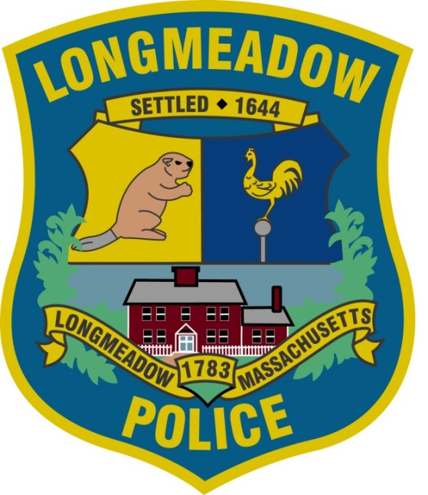

Longmeadow Police Department

Police Officer Entrance Examination
Registration Information

Exam date:
Saturday, September 22, 2018
9:00 AM

Location:
Williams Middle School
412 Williams Street
Longmeadow, MA 01106

Check-in Time:
08:00 AM

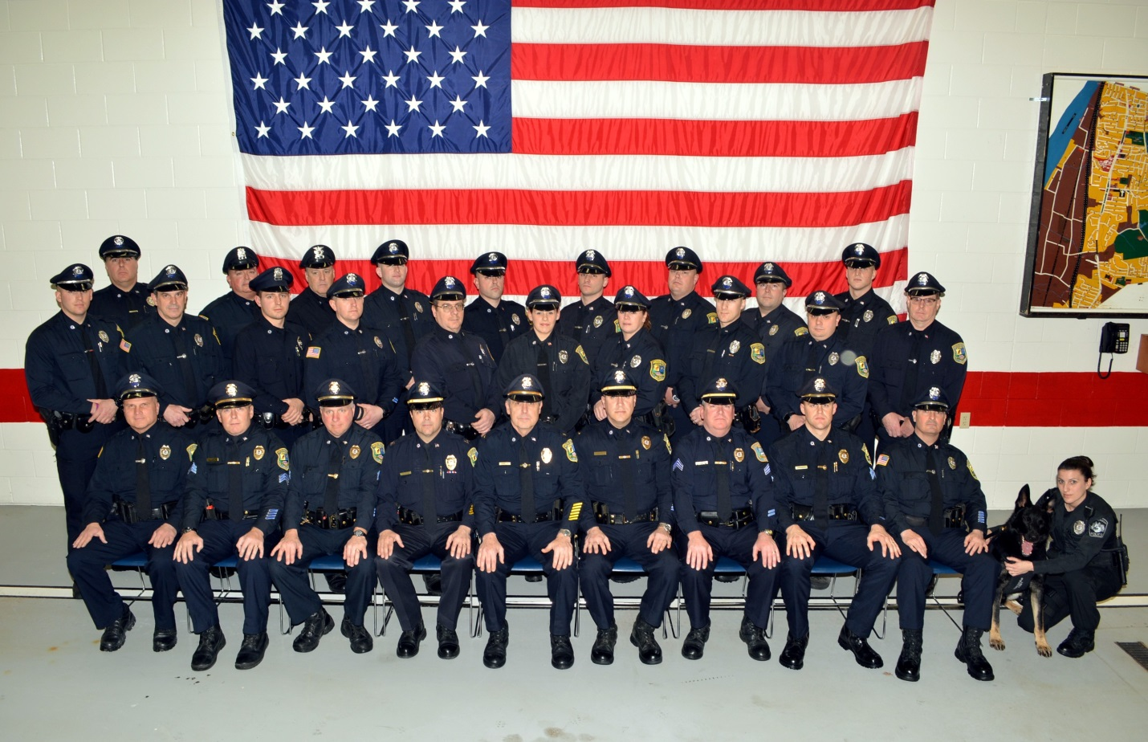

The men and women of the Longmeadow Police Department are committed to provide quality and professional policing, by continually partnering with the community to make the Town of Longmeadow, one of the safest in the Commonwealth.
Although most police departments throughout the country have similar responsibilities, the Longmeadow Police Department officers are unique in their delivery of services. You will find these patrol officers to be empathetic and committed to the problem solving philosophy.
Mission Statement
"The purpose of the Longmeadow Police Department is to serve the people of Longmeadow by ensuring the livability, safety, and security of the community through fair and impartial law enforcement."

Longmeadow Police Department

Police Officer Entrance Examination
Examination Details

Examination Date: Saturday, September 22, 2018, 9:00 AM
Examination Location: Williams Middle School, 412 Williams Street Longmeadow, MA
Registration Website: http://publicsafetyllc.com
Registration Deadline: Friday September 14, 2018
The Examination will be conducted by:
Public Safety Consultants, LLC
P.O. Box 1153
Pocasset, MA 02559
Contact: information@publicsafetyllc.com

THE TOWN OF LONGMEADOW IS AN EQUAL OPPORTUNITY EMPLOYER – AFFIRMATIVE ACTION

MGL 149 Sec 19 B “It is unlawful in Massachusetts to require or administer a lie detector test as a condition of employment or continued employment. An employer who violates this law shall be subject to criminal penalties and civil liability.”

Registration Guidelines
- To register, log onto http://publicsafetyllc.com. Click on the "Register" button at the top, and then choose the town for which you are registering.

- The cost of the examination is Eighty dollars. ($80.00 dollars).

- Payment must be received in full at the time of registration. (Credit card - PayPal - Electronic check) . No refund for Cancellation after 4:00 PM on Friday, September 14, 2018. Cancellation before 9:00 AM on Friday, September 14, 2018 will receive 50% refund.

- By registering for this examination, you acknowledge that you are eligible for and agree to all terms and conditions of the registration and examination.

- There are NO refunds if an applicant fails to show for the examination

- Special Accommodations: If you require special accommodations for this examination, you must contact the Examination Administrator in advance.

Admission to Examination
One day prior to the examination, you will be emailed an "Admission Notice" and an "application" by 7:00 PM.
You must bring the following documents to the examination:
1. Admission Notice - Signed
2. Filled out application
3. Government issued identification

Examination Check-in Procedure:
- Registration begins at 08:00 AM. Candidates should arrive by 8:30 AM

- Examination monitors will verify the following:

  - Applicants name, address, and email for test score notification

  - Valid government picture identification must be shown at check in

  - Application is submitted

  - You will then be assigned to a testing room

  - The examination will begin exactly at 9:00 AM and last approximately two hours.

- No food or drinks are allowed in the examination room.

- Absolutely NO electronic device (except medically necessary) is allowed in the examination room. You must leave all electronics including cell phones at home or in your automobile. A watch is acceptable.

- Bring a #2 pencil for the examination. (No gel pens or mechanical pencils)

Test Format

Though most of the questions in this test battery relate to police duty, no prior knowledge of law or law enforcement will be needed to answer the questions.

The Examination Monitor will read specific instructions prior to the beginning of each examination section.
Test Scores

Test results will be sent to each candidate and the Town of Longmeadow within 14 days of the examination via email. Applicants must obtain an overall minimum passing score of 70 %. All candidates receiving a total score above 70% will receive an email containing information from the Town of Longmeadow on how to proceed with the application process.

Minimum Qualifications:
- High School Diploma or G.E.D.

- Ability to obtain a valid Massachusetts firearms license

- At least 21 years old

- Must pass the entrance examination

- Must pass oral interviews

- Must pass a thorough background investigation prior to employment.

- Must pass a physical fitness test

- Must pass a medical examination

- Must pass a psychological examination

- Must be a United States citizen upon appointment to the Police Academy

- Must have a valid driver's license

- Must reside within 15 miles of Longmeadow, Massachusetts

- In accordance with M.G.L. Chapter 22 C section 10, no officer or student officer appointed or hired after January 1, 1988 shall smoke any tobacco product.

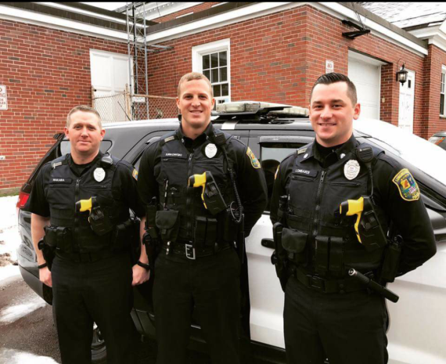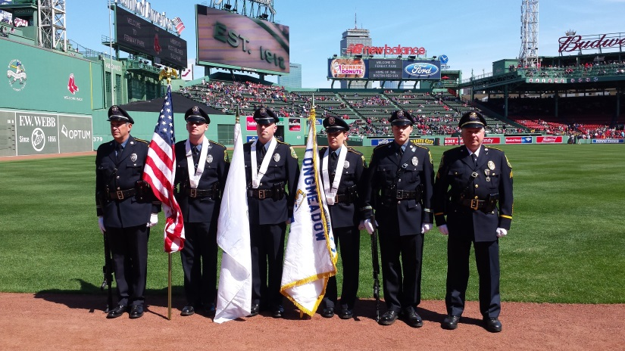
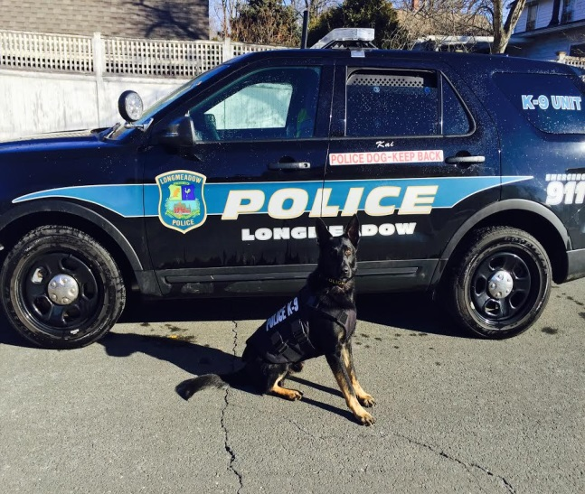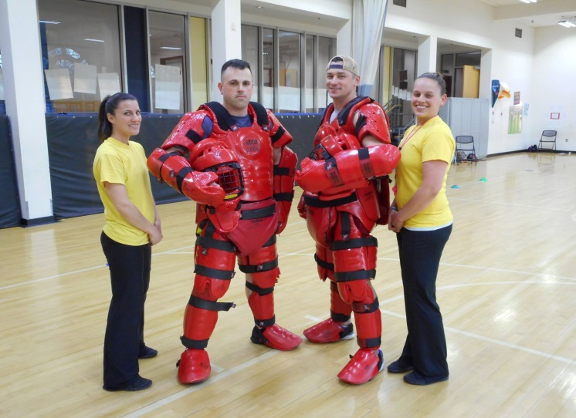
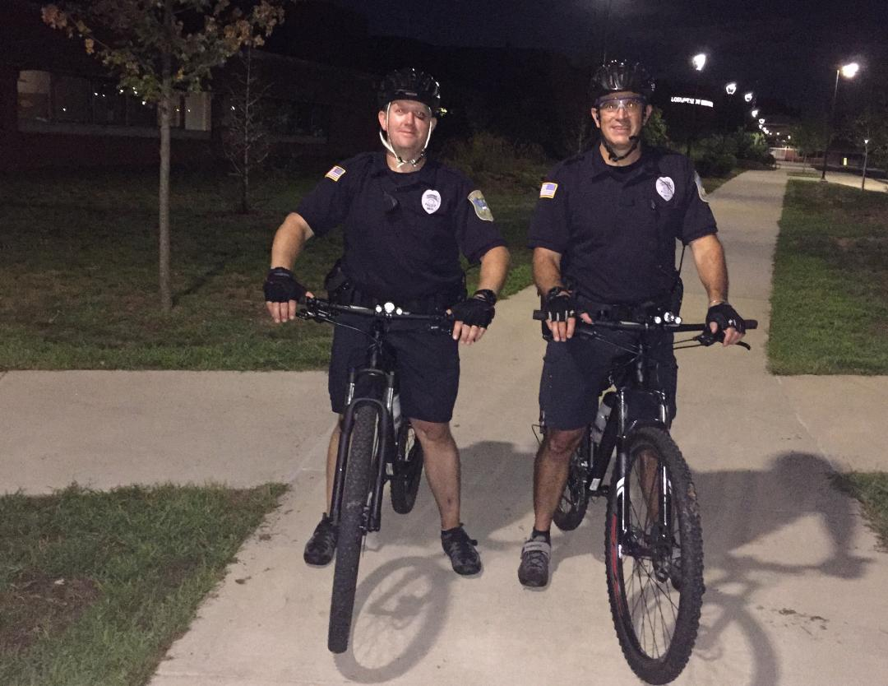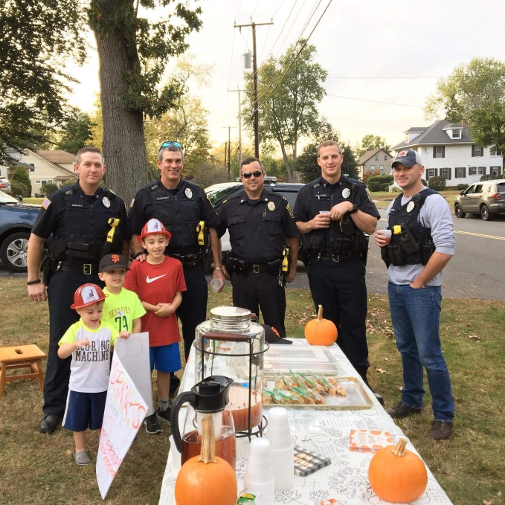

The Town of Longmeadow is nine square miles bordered by the City of Springfield to the north, the Connecticut River to the West, Enfield Connecticut to the south and East Longmeadow to the east. Interstate 91 and Amtrak railway bisects the town. The current population is 15,588 with 5,710 residential homes. There are several small business districts throughout town that include both national chains and independent businesses comprising restaurants and upscale retail shops. The Longmeadow School District has a high school, two middle schools and three elementary schools. Bay Path University’s main campus is located on Longmeadow Street. The town has three parks that are utilized frequesntly and the extensive sidewalk system and bike routes encourage pedestrian travel.
The Longmeadow Police Department is a progressive and professional police agency. We pride ourselves with the exceptional level of service provided to our citizens and the visitors of our community. As a certified police agency, we are focused on crime prevention, detection, and the quality of life of our residents and as a Massachusetts Police Certified Department, we adhere to the very best police practices in the field.

While we maintain a strong commitment to those outside of our department, we are also committed to creating and maintaining a positive internal work environment. Employees are provided opportunities for professional growth in pursuit of their own interests within the field. We support the physical and mental fitness of our staff. Agency leaders also strive to provide an atmosphere where officers have opportunities to engage with community members in positive ways and to contribute to the betterment of the town and the department.
Officers are provided with high-quality equipment and therefore are best prepared to respond effectively to the needs of our community.
Police Website: www.longmeadow.org/219/Police-Department
Find us on twitter and Facebook
Town Website: www.longmeadow.gov
Police Facebook: Longmeadow Police Department (Official)
Police Twitter: @longmeadowMApolice
Longmeadow Police Department
Number of Employees 33
Sworn Officers 27
Rank Structure 1 Chief, 1 Capt, 1 Lt, 5 Sgts, 19 Patrol Officers
Chief of Police John D. Stankiewicz (413-565-4192)

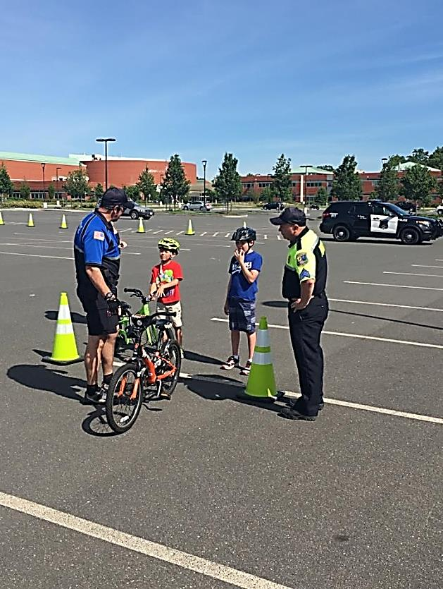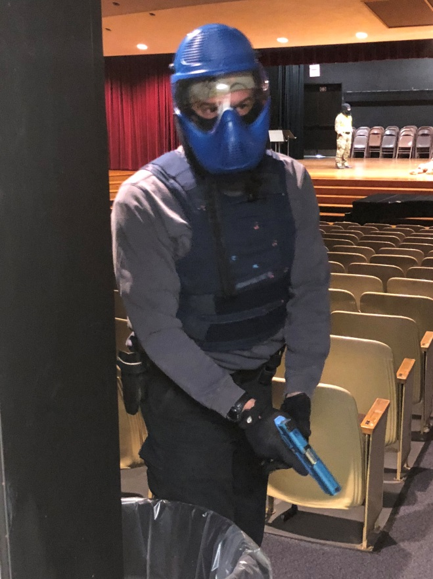

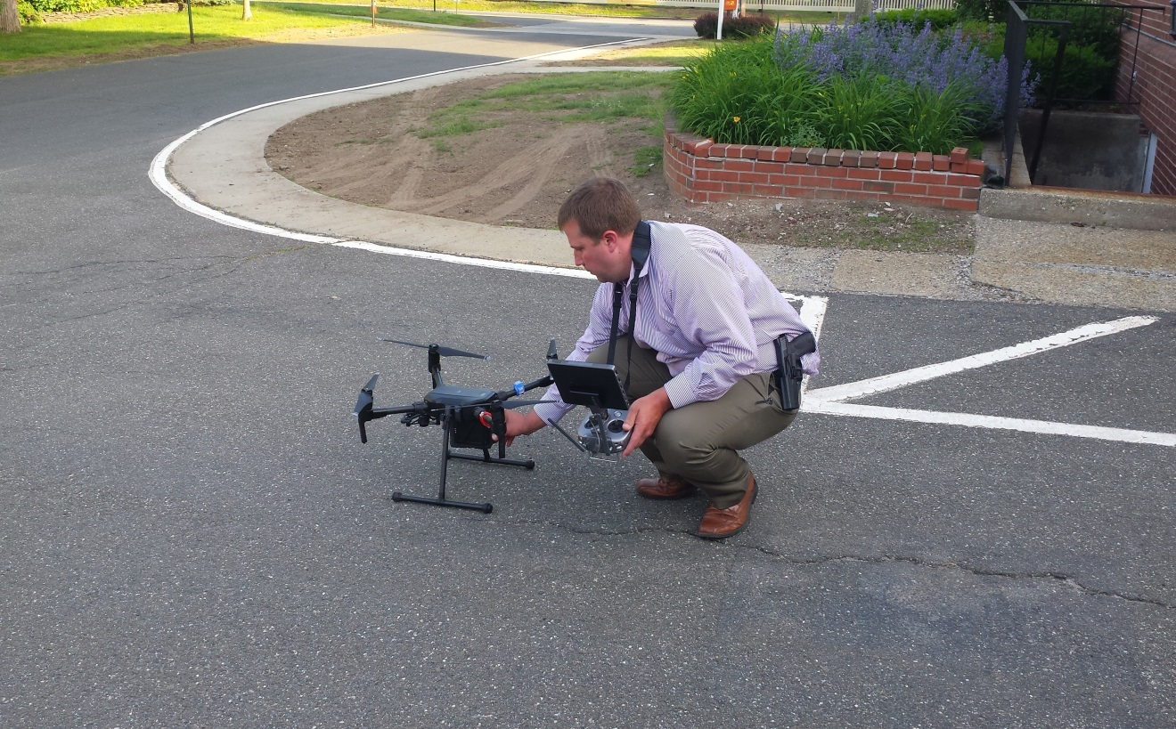

Some of the specialized units within our Department include:
- Detective Bureau
- SRO (School Resource Officer)
- K9 Patrol
- Bike Patrol
- Drug Task Force
- Firearms Instructor
- Taser Instructor
- Traffic/Safety Officer
- S.A.L.T (Seniors and Law Enforcement working Together)
- Honor Guard
- Drone Deployment
- Patrol Boat for emergencies on the Connecticut River

Programs offered to the Community:
- RAD (Rape Aggression Defense)
- Citizens Police Academy
- Bike Rodeos and bike safety seminars
- Various classroom visits including: Officers reading to students, Walking School Bus
- Public Safety Open House
- Various other programs to better serve the Community

Officers will be trained to handle:
- Firearms
- Tasers
- Intoxilizer
- Medical kits to assist the Longmeadow fire Department EMS in assisting injured persons
- Naloxone HCI (Narcan ) to counter the effects of an opioid overdose
- Active Shooter and other critical incidents

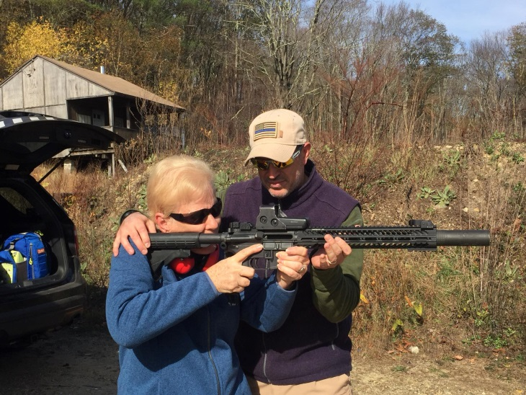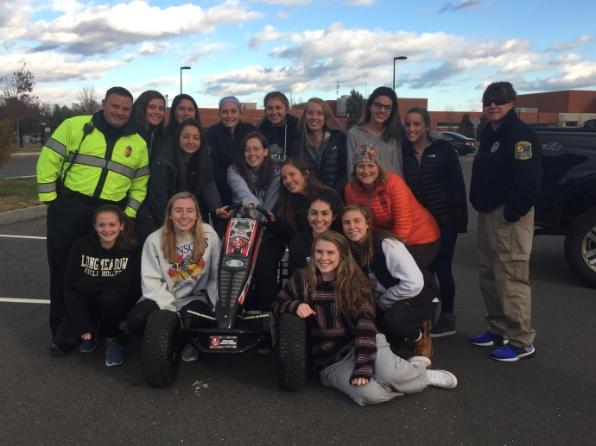
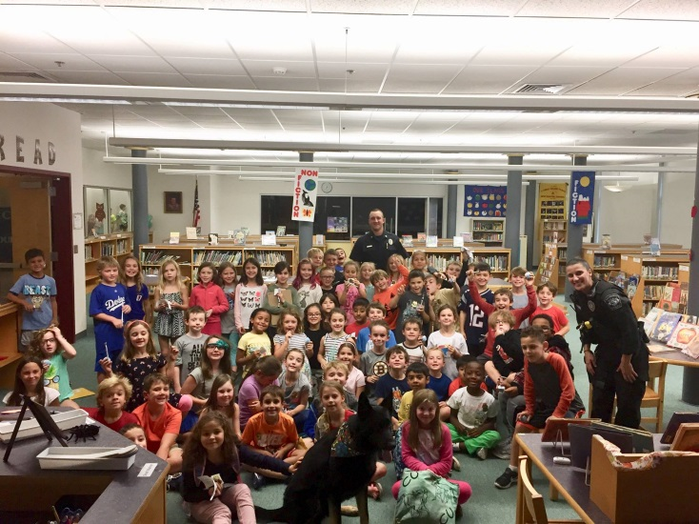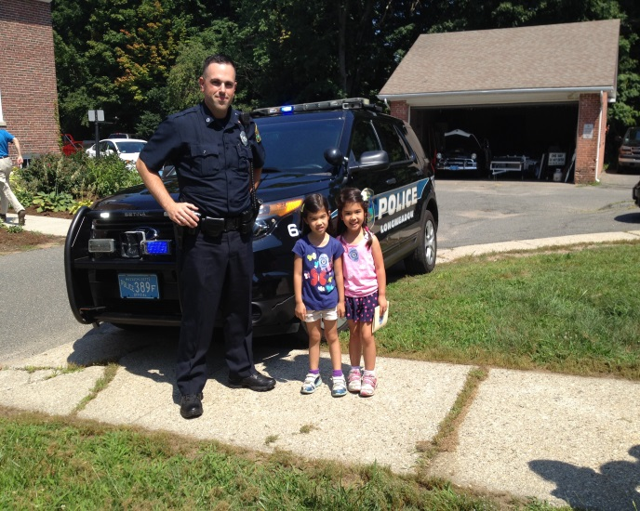
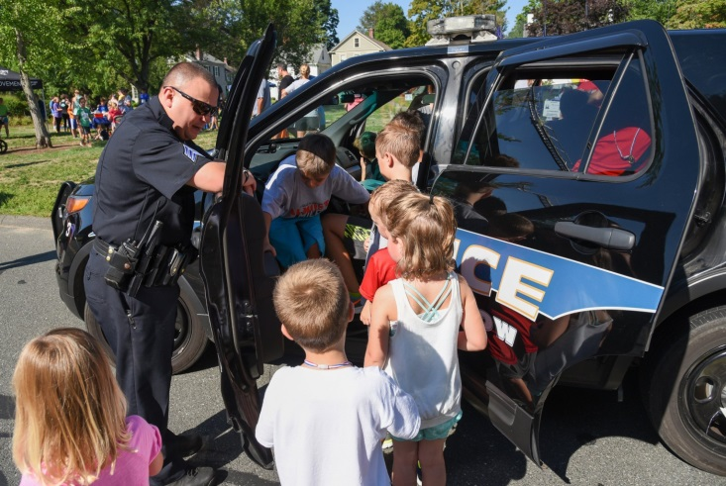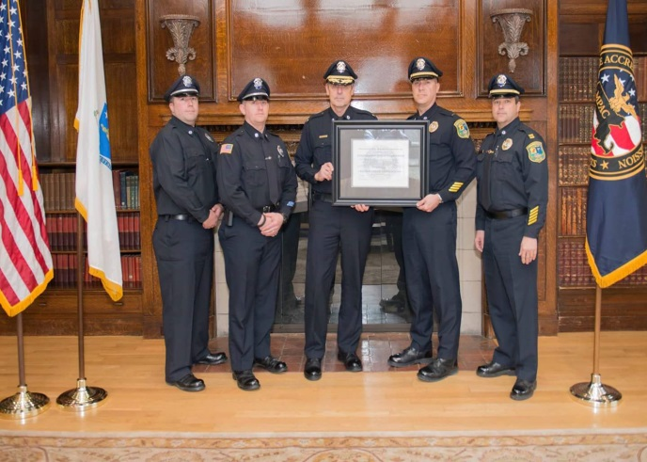

Additional Information
- Starting Salary $45,389-$59,337 annually plus a 15% base pay education stipend for a bachelor’s Degree or greater in Criminal Justice or other equivalent degree as determined by the town manager from an approved and accredited institution.
- Work Hours: 4 & 2, 8 hours following probation.
- Health insurance (eye and dental benefits available)
- Twelve paid sick days per year including five family sick days
- Maternity and paternity leave
- Up to 24 vacation days per year
- 3 personnel days
- Hampden County Retirement
- May voluntarily enroll in a deferred compensation program for retirement investing
- Detail Rate $48.04
- Overtime
- Paid Training

Responsibilities of a Longmeadow Police Officer

Summary
Patrol Officers shall be responsible for the efficient performance of required duties in conformance with the rules, regulations and policies specified by the Administration and Operations Manual. Subject to the direction and control of a superior officer, an individual holding the rank of Police Officer performs a number of general police responsibilities necessary to the stability and safety of the community.

General Duties and Responsibilities:

The essential functions, duties and responsibilities of a police officer are extremely wide and varied, and include (but not limited to) the following:

- Engage individuals and organizations to develop solutions to problems and increase public trust.

- Project confidence, safety, self-assurance and certainty to the public, and the ability to project a neat, professional appearance to the public.

- Exercise authority consistent with the obligations imposed by the oath of office and be accountable to superior officers. Promptly obey legitimate orders.

- Coordinate efforts with those of other members of the department so that teamwork may ensure continuity of purpose and maximum achievement of police objectives.

- Communicate to superiors and to fellow officers all information obtained which is pertinent to the achievement of police objectives.

- Respond punctually to all assignments. Be available to respond to calls for service until released from duty by the shift supervisor.

- Take police enforcement action, including custodial arrest, as appropriate in cases of violations of local by-laws, state laws or other controlling statutes within the jurisdictional boundaries of the Longmeadow Police Department.

- Assist all citizens requesting assistance or information. Courteously explain any instance where jurisdiction does not lie with the Police Department and suggest other procedures to be followed.

- Answer questions asked by the general public, counsel juveniles and adults when necessary and refer them to persons or agencies where they can obtain further assistance.

- Record activity during his/her tour of duty in the manner consistent with existing policy and procedure.

- Acquire information and familiarize themselves with events that have taken place since their last tour of duty.

- Confer with court prosecutors and testify in court.

- Serve or deliver warrants, summonses, subpoenas, and other official papers promptly and accurately when so directed by a superior officer.

- Maintain police firearms, weapons and equipment in a functional and presentable condition. Report damage or loss of equipment to the proper authority immediately, as prescribed.

- Be accountable for the securing, receipting and proper transporting of all evidence and property coming into custody (consistent with AOM policies).

- Perform other general duties as they are assigned or required by proper authority.

- Patrol a specific beat by radio patrol car, on foot, bicycle, or by other means for general purposes of crime prevention and law enforcement. Police patrol should be random, in order to prevent identifiable patterns from developing.

- Being thoroughly familiar with the assigned patrol area. Such familiarity includes the knowledge of residents, merchants, businesses, streets, alleyways, paths, etc. Conditions that contribute to crime should be reported.

- Apprehending persons violating the law or wanted by the police.

- Completing detailed professional reports regarding the investigation of all crimes, vehicle accidents and other incidents requiring police attention. In cases where an arrest is made, submit an arrest report along with the required crime reports. When property is recovered or additional information is discovered pertaining to a previously reported offense, complete an investigation report.

- Preserving any crime scene until a shift supervisor or detective arrives, when such crime scene is encountered or when dispatched to the scene as the first responding officer.

- Public assembly checks.

- Building security checks.

- Observing and addressing suspicious persons.

- Reporting street light and traffic signals out-of-order, street hazards and any other conditions that endanger public safety.

- Checking of schools, parks and playgrounds.

- Responding to any public emergency.

- Respond to situations brought to the Officer’s attention while in the course of routine patrol or when assigned by radio. Render first aid, as qualified, to persons who are seriously ill or injured. Assist persons needing police services.

- Remain within the assigned patrol area throughout the tour of duty except when a police emergency, as defined by policy, necessitates a temporary absence, or when a superior officer or the Dispatcher has issued authorization for a temporary absence. Notify the Shift Supervisor if more than a temporary absence from regular duties is required.

- Patrol assigned area giving particular attention to and frequently rechecking locations where the crime hazard is great. Insofar as possible, a Police Officer shall not patrol an area according to any fixed route or schedule, but shall alternate frequently and backtrack in order to be at the location least expected (when practicable).

- Be alert for all nuisances, impediments, obstructions, defects or other conditions that might endanger or hinder the safety, health or convenience of the public within the patrol area.

- Direct and expedite the flow of traffic at assigned intersections, keeping in mind the duty of preventing accidents, protecting pedestrians and ensuring the free flow of traffic.

- Issue traffic citations and enforce the parking ordinances and motor vehicle laws in the patrol area.

- Be alert for traffic safety conditions, which may endanger or inconvenience the public and report such conditions to proper authorities and render assistance if practicable.

- Officers directing traffic shall wear the prescribed traffic safety clothing and equipment as required.

- Conduct a thorough investigation of all offenses and incidents within the area of assignment and scope of activity. Collect evidence and record data that will aid in identification, apprehension, and prosecution of offenders, as well as the recovery of property.

- Conduct interviews and interrogations as appropriate to the investigation.
- Prepare affidavits, warrants and court complaints as required and appropriate.

- Enforce the law impartially and to make sound judgments under stressful situations.

Professional Responsibilities

Police officers are professionals, and, as such, are expected to maintain exceptionally high standards in the performance of their duties.
Effective and efficient performance of his duty requires that a police officer maintain the respect and cooperation of his community. This requirement dictates that the conduct of all police officers be above reproach in all matters both within and outside the Department.

General professional responsibilities include taking appropriate action to:

- Protect life and property;
- Preserve the peace;
- Prevent crime;
- Detect and arrest violators of the law;
- Enforce all laws coming within departmental jurisdiction;
- Supervise public functions (such as parades or athletic events) where public order requires police presence;
- Respond to all public emergencies; and
- Endeavor to maintain good community relations.

Uniforms

The primary reason police officers wear uniforms is to make them readily identifiable and hence, readily accessible to the citizens they serve. Our citizens need and are comforted with the sense of safety and security provided by a visible police presence. Moreover, crime and disorder are deterred by a visible police presence. Our citizens’ general opinion of the police are not only based on our performance but also the way our officers look in the performance of their duties. Accordingly, officers of this department shall maintain a neat, clean and consistent appearance at all times and that the uniform they wear be easily identifiable as that of a Longmeadow Police Officer.

Appearance

Members shall be neat appearing and well-groomed while in uniform. All articles of clothing shall conform to the departmental uniform regulations (See AOM The Uniform and Equipment Policy.)

Rule 7.1 – Male Hairstyles
All male members shall report for duty clean- and with neat and trimmed haircuts. The hair shall not cover any part of the ears and will be trimmed on the back and sides so that it does not extend over the collar. Hair in front will be groomed so that it does not fall below the band of properly worn headgear.

Rule 7.2 – Mustache and Beards
The face will be clean-shaven, except that mustaches are permitted. If a mustache is worn it will be kept neatly trimmed and tidy – no portion extending beyond the corners of the mouth will fall below a line parallel with the bottom lower lip. Goatees and beards are not authorized (unless with express permission from the Chief of Police).

Rule 7.3 – Female Hairstyles
Hair will be clean, neatly styled, and pinned up against the head so that it is above the shirt collar. Longer hair will be fashioned up, and all hair styles must be such as to stay in place and not hang over the eyes.

All sworn female personnel shall conform with the following criteria:
Hair will not be worn in any style longer than collar length and must not be worn in a style that prevents the proper wear of a uniform hat or cap. Hair ornaments such as ribbon will not be worn. Pins, combs or barrettes similar in color to the individual’s hair color may be worn.

Rule 7.4 – Wearing the Uniform
Uniforms shall be kept neat, clean, and well pressed at all times. Care should be taken not to wear threadbare or faded items. The Chief shall periodically issue special orders pertaining to daily or seasonal wear.

Rule 7.5 – Miscellaneous
All sworn personnel shall adhere to the following miscellaneous criteria:

- Lipstick, rouge, eye shadow, false eyelashes, fingernail polish or jewelry, such as excessive rings shall be prohibited.
- Wedding, engagement, fraternal, school, initial rings or other rings of similar size and appearance shall be the only rings authorized for on-duty wear.
- Male Officers may not wear earrings or studs on duty. Female Officers may wear only stud-type earrings on duty (one per ear, no hoops or dangling styles). Earrings that do not extend past the ear lobe are allowed.
- No Officer may wear facial jewelry while on duty (with the exception of the aforementioned earrings).

Rule 7.6 – Civilian Clothing
Male members and employees permitted to wear civilian clothing during a tour of duty shall wear either a business suit, sports coat and slacks or a dress-style shirt with dress slacks (business casual). While assigned to a dispatch function, the employee may wear dress slacks and a collared shirt. Shift Supervisors may prescribe other types of clothing when necessary to meet particular police objectives.

Unless otherwise directed, female members and employees permitted to wear civilian clothing shall conform to standards normally required of office personnel in private business firms.

Rule 7.7 – Tattoos, Body Art, and Brandings

Due to their public and professional standing, members of the Department must not present an image that may be misconstrued as offensive or unprofessional. Employees, while on duty, are prohibited from displaying tattooing, body art, or brandings, which are likely to be socially offensive. No Officer shall have tattoos on any part of their body which is visible while wearing the police uniform (Arm tattoos may not extend more than 2 inches below the short-sleeve uniforms). No Officer may appear in uniform with any visible tattoo or decal on the hands, head, face, neck fingers or wrists.

Also, those displays that advocate or symbolize gangs, supremacists, extremist beliefs, drug use or sexual discrimination are prohibited. The Chief of Police, or his designee, will render the final judgment in these matters.

Law Enforcement Code of Ethics

As a law enforcement officer, my fundamental duty is to serve mankind; to safeguard lives and property; to protect the innocent against deception, the weak against oppression or intimidation, and the peaceful against violence and disorder; and to respect the Constitutional rights of all persons to liberty, equality, and justice.
I will keep my private life unsullied as an example to all; maintain courageous calm in the face of danger, scorn, or ridicule; develop self-restraint; and be constantly mindful of the welfare of others. Honest in thought and deed in both my personal and official life, I will be exemplary in obeying the laws of the land and the regulations of my department.
What I see or hear of a confidential nature or that is confided to me in my official capacity will be kept ever secret unless revelation is necessary in the performance of my duty.
I will never act officiously or permit personal feelings, prejudices, animosities, or friendships to influence my decisions. With no compromise for crime and with relentless prosecution of criminals, I will enforce the law courageously and appropriately without fear or favor, malice, or ill will, never employing unnecessary force or violence, and never accepting gratuities.
I recognize the badge of my office as a symbol of public faith, and I accept it as a public trust to be held so long as I am true to the ethics of the police service. I will constantly strive to achieve those objectives and ideals, dedicating myself to my chosen profession – law enforcement.
Source: Based on the IACP, Law Enforcement Code of Ethics

